Letter Management System 2.0

Product Requirements Document(PRD)

Prepared by:
Felix Morales Pareja

Table of Contents

- Project Overview
1.1 Purpose
1.2 Core Concept
1.3 Key Features

- User Roles & Permission

- User Stories

- Current Workflow

- Dependencies

- Non-Functional Requirements
  - Security & Compliance
  - Performance & Scalability
  - Usability & Accessibility
  - Availability & Reliability.

- Use Case Diagram

- Workflow Diagram

- Testing Requirements
9.1 Functional Testing (Manual)
9.2 Production Server Deployment

- Project Overview
The LMS 2.0 (Letter Management System) is a web-based application designed for the digital tracking, archiving, and management of the workflow of letters arriving at every department, section, and team within the Central Office.

  - Purpose
LMS 2.0 is a digital Letter Management System. It tracks, archives, and manages official letters. It routes letters smoothly across different departments, sections, and teams.
- Go Paperless: Replace manual logbooks with a fast digital system.
- Find Records Fast: Search for letters quickly using tracking IDs (like ATG#, VEM Number, AEVM Number, Sender, Re).
- Ensure Accountability: Ensure accountability in every section and department through letter tracking. This will track the exact location and current status of each letter.
- Simplify Uploads: Make uploading PDF files to existing letters easier by scanning the ATG# printed on the letter.

  - Core Concept
LMS 2.0 acts as a routing engine. A letter is not just saved in the system. It is assigned to specific people or teams for action.

  - Key Features
- Unified Inbox: See all the letters you need to work on in one central place
- Flexible Workflow: Send letters to different departments easily.
- Audit Trail: Keep a clear history of every change, comment, and endorsement.
- Tray Management: Link digital letters to their physical filing trays.
- File Attachments: Pag-upload ng scanned copies ng mga sulat para mabilis na viewing.

- User Roles & Permissions
The system uses strict roles and an Access Matrix. Users only see what they are allowed to see.

- Administrator: Full control. They can manage users, settings, and permissions.
- VIP: This is used when the subject is out of the country (abroad). All letters requiring a signature and comments can be found here.
- Encoder: Creates new letter records, manage letters, and uploads PDF scanned files.
- User: They only see letters that are assigned to their specific section or team.

- User Stories
User stories help explain exactly what each role needs to do in the system.

- Admin / Developer
Story: As an Admin, I want to assign a new letter to a specific department and choose the correct workflow step.
- VIP
Story: As a VIP, I want to see the status of every letter across all departments so that I can sign them and add comments to the letters.
- Encoder
Story: As an Encoder, I want to type in details for a new letter and upload a scanned PDF copy so the digital tracking can start.
- User
Story: As Staff, I want to look at my "Inbox" and only see letters assigned to my own department/section/team.

- Current Workflow
This is how a letter moves through LMS 2.0 from start to finish:

- Submission: An Encoder inputs a new letter. Guests can also submit letters via an external portal. The system creates a unique tracking ID automatically.
- Assignment: The letter is officially assigned to a department/section to handle.
- Inbox Processing: The assigned team sees the letter appear in their "Unified Inbox".
- Endorsement: The team works on the letter. They add comments or instructions. They can then "endorse" (forward) the letter to the next department or process step.
- Instant Notifications: Every time a letter moves or gets endorsed, the Telegram bot sends an alert to the next team.
- Completion: The letter is marked as Filed or Resolved. Physical copies are mapped to their real-world Trays.

- Dependencies
- Telegram Bot API: The real-time notification feature depends entirely on the availability of the external Telegram API webhooks. If Telegram is blocked or down, notification delivery will fail, though core letter routing will remain unaffected.
- Legacy PHP System Sync: Pulling historical records depends on the uptime and network accessibility of the legacy database host (172.18.162.84).

- Non-Functional Requirements

6.1 Security & Compliance
- Access Restraints: All data exchanges regarding system pages, users, and documents must pass through a strict authentication middleware validation. Unauthenticated requests must lock out immediately.
- Data Masking: Sensitive administrative fields and account credentials must never be rendered or exposed in client-side storage structures.

6.2 Performance & Scalability
- Page Load Response Time: The React UI frontend must render data elements (such as the Unified Inbox) within 2 seconds under normal local network operations.
- Database Query Resolution: Relational joins across tables (e.g., matching letter parameters to current process steps) must complete execution in under 500ms.

6.3 Usability & Accessibility
- Theme Standards: The interface must maintain a modern corporate design style utilizing clean glassmorphism effects alongside a specialized Emerald and Modern Corporate Blue color scheme to minimize eye strain.
- Responsive Layout Shifts: The platform must dynamically adjust to varying display types, collapsing side menus automatically on tablet and mobile interfaces while preserving text readability.
6.4 Availability & Reliability
- Operational Window: The system target uptime is 99.5% during core Central Office business operating hours.
- Graceful Degradation: If connection to the backend server drops, the client interface must catch the error gracefully and present a clean notification toast instead of crashing or serving a blank screen.

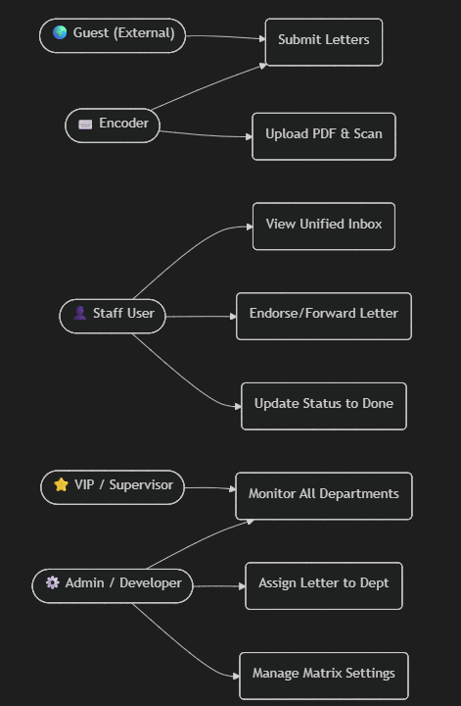
- Use Case Diagram

- Workflow Diagram

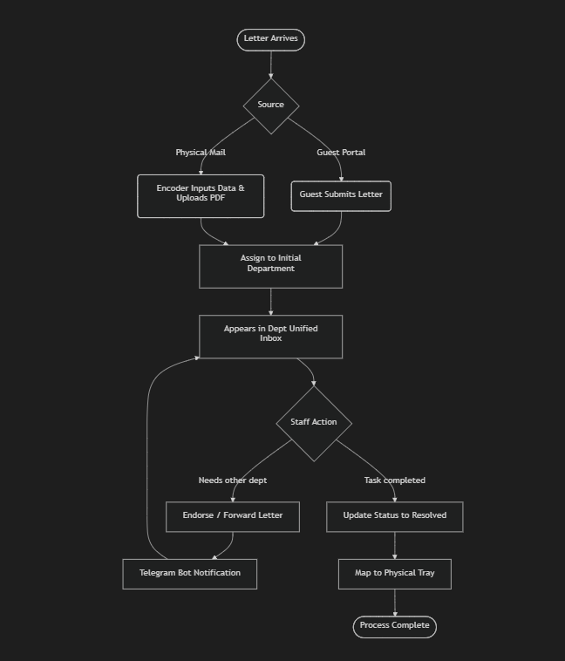

- Testing Requirements
To ensure the system is secure and works perfectly, testing is divided into three main areas.

9.1 Functional Testing (Manual)
Manual scenarios to verify that the LMS 2.0 works exactly as the business logic intends.

🔑 Authentication & Session Routing
- Verify that navigating directly to /users or any dashboard URL while unauthenticated immediately redirects the user back to the Login Page.
- Test the login form using valid and invalid credentials for different system roles (Felix, Admin, Team Leader, etc.).
- Verify that clicking "Logout" clears the session immediately and prevents the user from using the browser's "Back" button to see cached dashboard data.

📑 Letter Management & Dynamic Routing
- Verify that creating a new letter assigns it a unique ATG# and places it in the correct initial department queue.
- Test the Dynamic Routing Engine: Ensure a letter successfully transfers state and visibility when passed from a Team Representative to a Team Leader, and finally to a VIP.
- Verify that a standard department user cannot see letters restricted to other sections or teams.

🌟 VIP Module & Signatures
- Verify that the VIP Module correctly displays all letters currently pending signature across all departments when a VIP user logs in.
- Test the signature feature: Ensure a VIP can successfully sign a letter and that the letter's status updates immediately.
- Test the commenting system: Ensure VIP comments are saved, tied to their user ID, and viewable by authorized sections.

🖨️ ATG# Barcode Scanning & PDF Upload
- Test scanning a printed ATG# barcode using a hardware scanner or input emulator to see if it pulls up the correct, existing letter workspace.
- Verify that uploading a PDF file attaches it directly to the scanned letter without breaking existing metadata.
- Test uploading invalid files (e.g., .exe, .mp3) to ensure the system rejects them with a helpful error message.

